Quiz 9: Circulatory System Anatomy and Basic Functions

Name: ______________________________________ Date: Jan. 23, 2014.

Label the Heart Diagram using the word list provided. Each answer is worth 1/2 mark each.

Word List: Superior vena cava Right pulmonary artery Right pulmonary veins
Right atrium Rt. AV Valve (Tricuspid) Right ventricle
Inferior vena cava Left pulmonary artery Left pulmonary veins
Left atrium Lt AV Valve (Bicuspid) Aorta
Left ventricle Septum
- __________________________
- __________________________
- __________________________
- __________________________
- __________________________
- __________________________
- __________________________
- __________________________
- __________________________
- ________________________
- ________________________
- ________________________
- ________________________
- ________________________

______ / 7
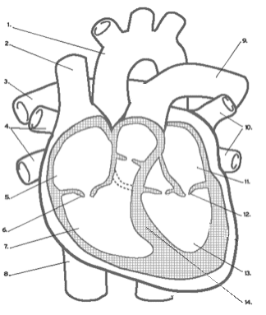

Fill in the blanks using the words provided: ____ / 8

Aorta Veins Arteries Pressure Circulates Oxygen

Nutrients Waste CO2

1. Blood pumping through our arteries causes ___________on them.

_________________ are important because they carry blood from the body back to the heart.

2. Our blood __________________ through our body in our blood vessels.

3. The _______________ is the biggest artery in the body and its attached to the Left Ventricle.

4. The circulatory system carries _______________ and ______________ to our cells, and take

__________________ and __________________ away.
Types of Blood Vessels: ______ / 9

With the features listed below, write the correct 3 in each of the spots provided for each blood vessel diagram.

Features: Medium-sized blood vessels Tough, flexible and thick walls

Carries blood back to the heart The Smallest blood vessels

Thin Walls due to less blood pressure Carries blood away from the heart

Walls are only one-cell thick The largest blood vessels

Exchanges oxygen and waste with the blood

Arteries | Capillaries | Veins
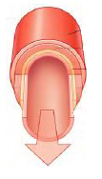  List the 3 features from above | 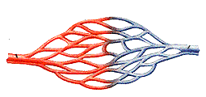  List the 3 features from above | 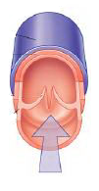  List the 3 features from above
1.________________________________________________ | 1.______________________________________________________ | 1.__________________________________________________
2._________________________________________________ | 2.____________________________________________________ | 2._________________________________________________
3._________________________________________________ | 3.____________________________________________________ | 3._________________________________________________

Multiple choice Questions: Each is worth one mark; CIRCLE THE MOST CORRECT ANSWERS.

1. Why is oxygen important to blood and to the cells? ____ / 10

Oxygen helps the blood to clot.

Oxygen brings food to the cells.

Oxygen is necessary for cell growth and energy.

Oxygen is not important -- carbon dioxide is the most important substance to the body.

2. Which type of blood vessels carries blood away from the heart?

Veins Arteries Capillaries Arteries, veins and capillaries

3. When oxygen-rich blood leaves the lungs for the heart, it enters the heart through the pulmonary vein into the __________________

left ventricle right atrium right ventricle left atrium None of these

4. How many times does the average adult heart beat per minute while at rest?

150 40 120 70 35

5. A pulse is caused by ________________.

the valves in an artery opening and closing

oxygen entering the blood in the lungs

red blood cells colliding with each other in the arteries

changes in blood pressure in an artery

6. Which one of the following is NOT a blood vessel?

Capillary Artery Colon Vein The all are blood vessels

Use the heart diagram on the right to answer the next 2 questions…
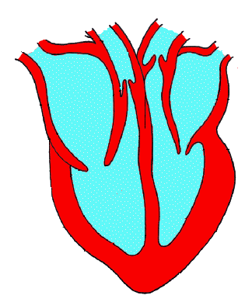
7. How many blood vessels leave the heart?

2 4 1 3

8. Which part of the heart has the thickest walls?

Right ventricle Left atrium

Left ventricle Right atrium

9. The blood vessel that carries deoxygenated blood from the body to the right side of the heart is called the__________________.

Pulmonary vein aorta pulmonary artery vena cava(s)

10. Which one of the following describes a vein?

It has thin walls and carries oxygenated blood away from the heart.

It has thick walls with valves and carries blood under pressure.

It has a very thin wall with valves and carries blood under pressure.

It has thin walls with valves, and carries blood to the heart. _______ / 35

