
You’ll Flip Over these Cameras!

Flip Camera Project Ideas:
- Quick introductions video at the beginning of the year
- Record science experiments
- Students record their progress on science projects, etc.
- Weekly current events broadcast
- Record student plays or skits
- Narrated field trips with students serving as guides
- Students interviewing other students, faculty, or community members
- Digital storytelling projects
- Recording student presentations and reports
- Video scavenger hunts
- Take footage for student ePortfolios

Tips for Better Videos:
- With Flip cameras, it’s very important to keep your hand steady.
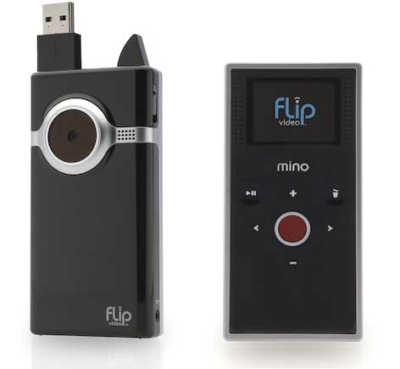
- Pan very slowly.
- Avoid using the zoom.

