
Getting Started

Training Options
Three excellent ways to familiarize yourself with Smartboard software are available right on the Smarttech.com web site in their Training Center section here http://smarttech.com/trainingcenter/

- Printable materials for Mac and Windows are available.
- Short Two Minute Tutorials are available here http://smarttech.com/trainingcenter/tutorials.asp
- Live online training is also available here. (Uses Bridgit software included.) http://smarttech.com/trainingcenter/online/index.asp

Setup and orientation procedures

Connectivity
Ensure the vga/dvi port from the computer is connect to the projector.
Ensure the USB cable connects computer to the Smartboard. A solid green light indicates the SB is connected correctly.

“Orientation” of the Smartboard
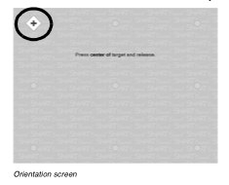
The mouse action of your computer must be oriented and aligned correctly to the exact dimensions of the Smartboard screen and Projector.

If it doesn’t ask when connecting, start up the Smartboard’s “Control Panel” and click Orient/Align the SMART Board. Or click both Keyboard and Mouse buttons simultaneously in pen tray.
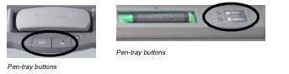

Touch the 9 target points to orient the Smartboard. (In some cases it is worth raising the number of touch points above 9 to increase accuracy. See Orient/Align settings in Settings button.)

Source: Mac Basics and Windows Basics

Universal Abilities and Tools
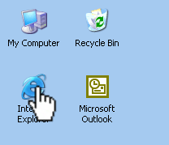
Once the Smartboard is connected, certain tools are available in ALL applications as part of the general functionality of the Smartboard itself.

- Fingers! Tap the screen for mouse click. Touch and drag to move objects.

- Pens! Different colours are available for circling, underlining, taking notes, etc.

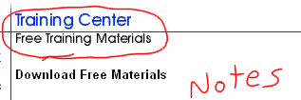

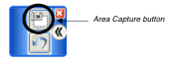
- Saving your notes! Capture tools are available for screen shots of an Area or the whole screen. Notebook software opens, if it is not already, and saves the capture as a new page. You may need to click the Restore writing button on your floating toolbar to get back to your notes for additional screen work.

Activity: Try navigating to a website and circulating key points on a page. Capture your notes and save them in a Notebook document.

Source: Mac Basics and Windows Basics
Also from tutorial: Touch, Write and Save

Smartboard NOTEBOOK Software

The included Notebook Software is an excellent alternative to Powerpoint software for presentation purposes, and also serves as a good interact space for students. One reason for this is that the document can be manipulated/edited while in full screen mode.
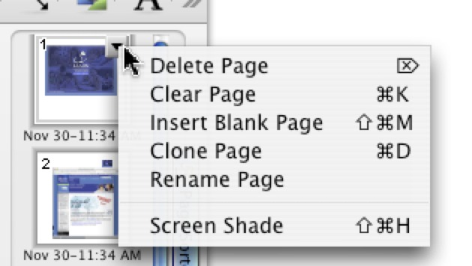
Pages (Slides!)
Notebook refers to slides as “Pages”. You can insert pages from the Insert menu, or from the drop down menu available on each slide. (See picture at right)

- Screen captures create new pages in notebook. Notebook isdifferent from other applications, in that any writing, drawing or other editing is automatically saved and immediately becomes part of the page.
- Pages are editable in full screen mode.
- Links on text or objects can jump to other pages in document.
- Pages can be “extended” to continue writing below.
- Pages can be revealed slowly using the screen shade option.

Tools available
Your fingers take on different functions depending on the tool that is selected!
Arrow moves an object Pen tools change your finger into a drawing or writing instrument.
Text tool creates a text box for typing. Click button in tray to bring up Keyboard to finger type.
Shapes including Word Balloons, are also available.

Objects can be inserted using the Insert menu option, or dragged from a “gallery” or from your computer to embed it into the Notebook file. (Includes: Images, Flash .swf files, Flash .flv files for video.) Objects and texts can be “linked” to either other pages or external web sites using object drop-down menu. See tutorial on object insertion.

Activity: Draw a little “scene” that includes a “textbox” title, Word balloons, writing, inserted pictures of two or more characters.
Toolbar reference describing Notebook abilities: Mac and Windows
Tutorials available here: http://smarttech.com/trainingcenter/tutorials.asp

Other SmartBoard included software

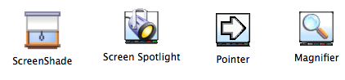
Other “Smartboard Tools” are available as included software packages. Mac users can browse the Smartboard folder for these tools. Windows users can access them via the Smart Board icon at bottom right of screen on task bar.
View this tutorial on the available tools

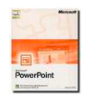
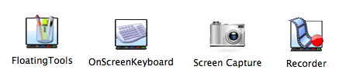
Other tools are also available on the floating tools toolbar or by opening them using the Smart Board icon.

Also, certain tools become active when viewing Microsoft Powerpoint slides, whereby penned notes can be inserted into the Powerpoint itself. See this tutorial http://smarttech.com/trainingcenter/tutorials.asp#

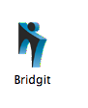
Bridgit is an included software used for online training and screen sharing.
It has audio and video conferencing capabilities!

See tutorial and printed info on training site (click Mac or Windows and search page for Bridgit)

